Tronghieu1989 password fafsa  
Tronghuy1989 usename  
Key no 1989

Jinsadp: ID: Huydao , Pw: tronghuy89

Nuskin: id [tronghuyj@yahoo.com](mailto:tronghuyj@yahoo.com) pw Huy-dao89

Sjsu:012039443 pw: Louisdao234

Adobe cloud: [huy.t.dao@sjsu.edu](mailto:huy.t.dao@sjsu.edu), thucao1989

Gmail pw huydao1989

Macpro

Huydung89

[Hdao424@yahoo.com](mailto:Hdao424@yahoo.com)

Tmobile huy031989

Ref comcast:730223

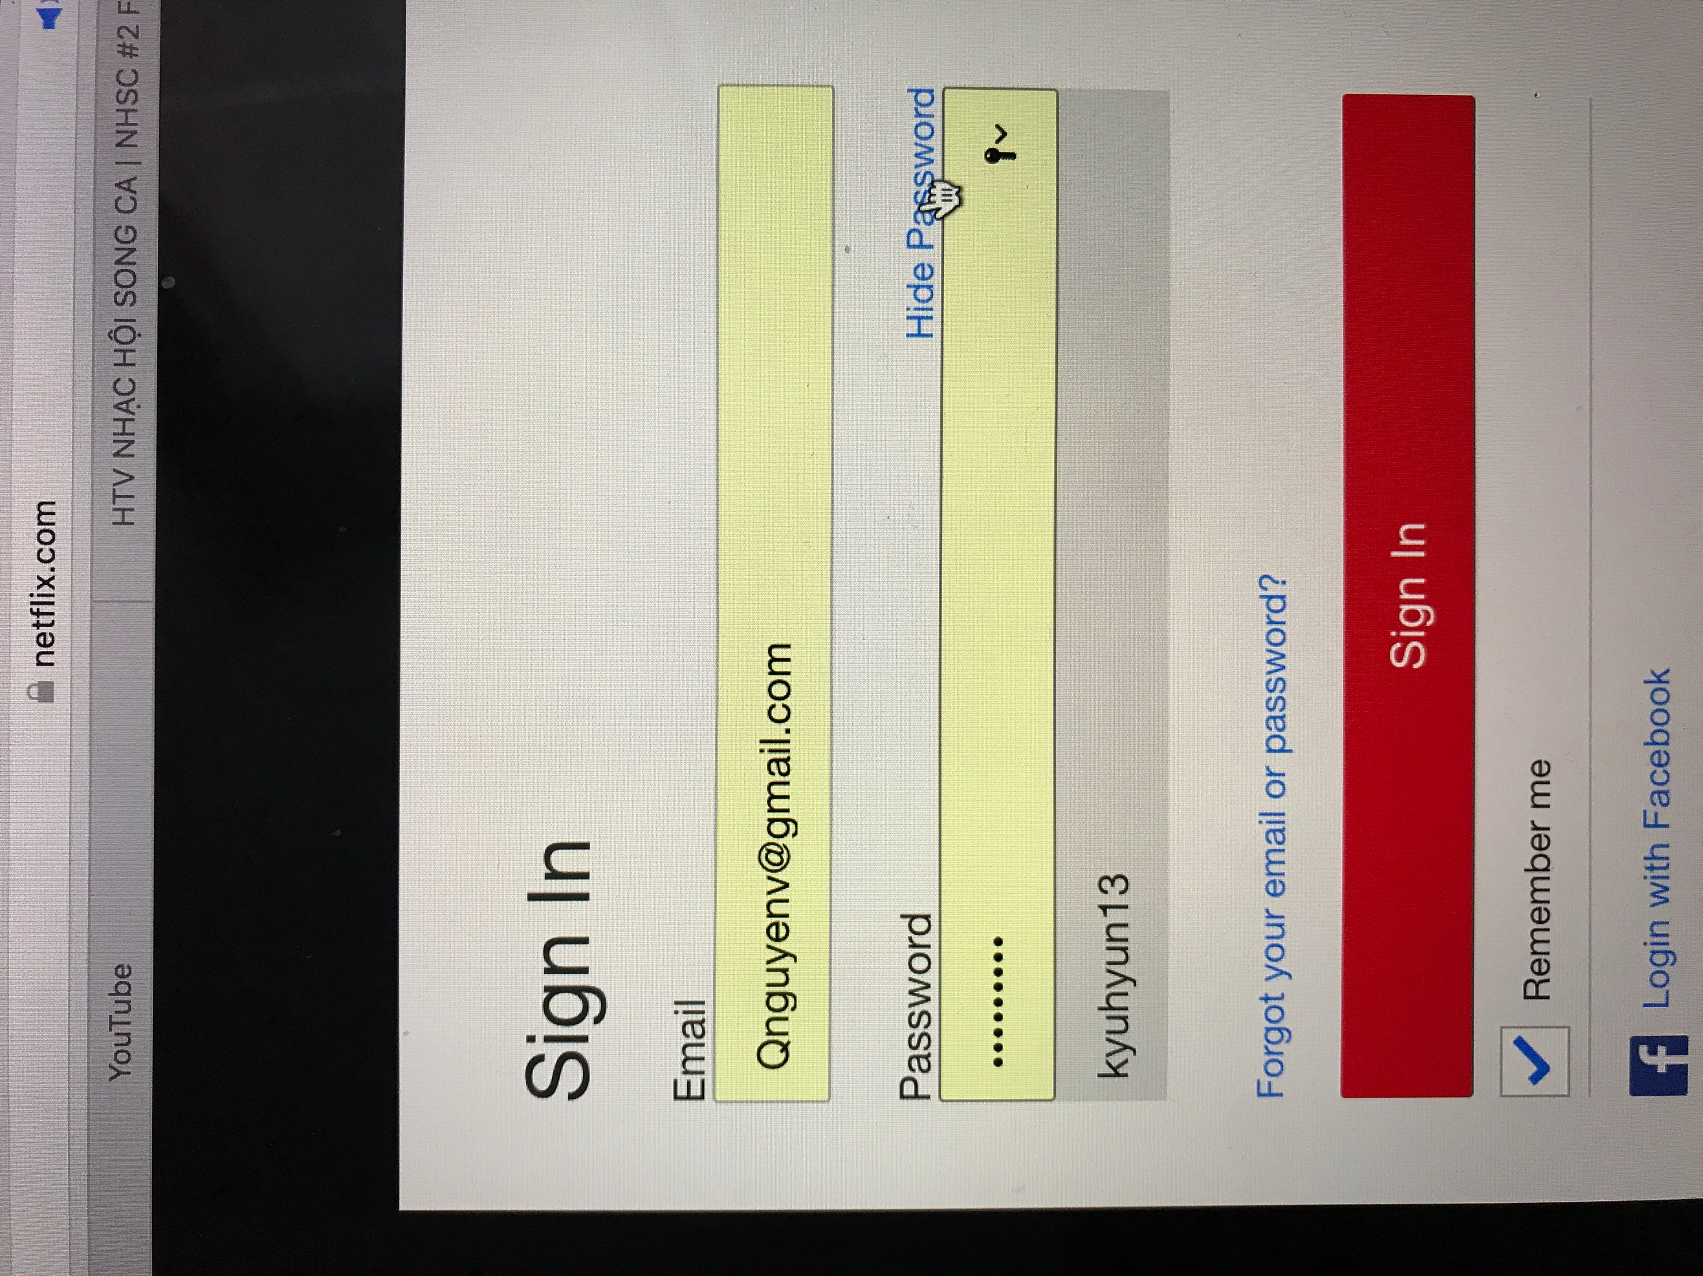

B0nb0nb0n